

Practices for Secure Software Report

Table of Contents
Document Revision History 3
Client 3
Instructions 3
Developer 4
1. Algorithm Cipher 4
2. Certificate Generation 4
3. Deploy Cipher 4
4. Secure Communications 4
5. Secondary Testing 4
6. Functional Testing 4
7. Summary 4
8. Industry Standard Best Practices 4

Document Revision History

Version | Date | Author | Comments
1.0 | 10/12/2026 | Taylor LaDuke

Client



Instructions

Submit this completed practices for secure software report. Replace the bracketed text with the relevant information. You must document your process for writing secure communications and refactoring code that complies with software security testing protocols.

- Respond to the steps outlined below and include your findings.
- Respond using your own words. You may also choose to include images or supporting materials. If you include them, make certain to insert them in all the relevant locations in the document.
- Refer to the Project Two Guidelines and Rubric for more detailed instructions about each section of the template.

Developer
Taylor LaDuke

Algorithm Cipher

Cipher Recommendation
For Artemis Financial, I recommend using the Advanced Encryption Standard (AES) with a 256-bit key to protect sensitive financial information. AES-256 is a symmetric encryption algorithm widely used to secure confidential data. It provides strong protection while maintaining efficient performance, making it appropriate for financial applications that process and store sensitive customer information.
AES-256 is particularly suitable for protecting stored data, including financial records, account information, and archived files. When implemented using Galois/Counter Mode (GCM), AES provides both confidentiality and authentication, helping detect unauthorized modifications to encrypted information. Secure key generation, protected key storage, and proper nonce management are essential to maintaining its effectiveness.
For information transmitted between clients and the Artemis Financial application, HTTPS with TLS should be used to establish encrypted communication. The application was configured to use HTTPS on port 8443 with a self-signed certificate for development and testing. In a production environment, Artemis Financial should use a certificate issued by a trusted certificate authority.
AES-256 and SHA-256 serve different security purposes. AES-256 encrypts sensitive information so unauthorized individuals cannot read it, while SHA-256 generates a cryptographic hash that can be used to verify data integrity. During this project, SHA-256 was implemented for checksum generation; AES-256 is a recommendation for protecting confidential data rather than a feature implemented in the application.

Certificate Generation
Insert a screenshot below of the CER file.

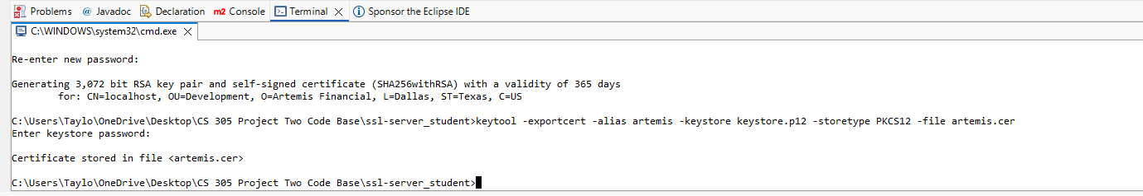

Deploy Cipher
Insert a screenshot below of the checksum verification.

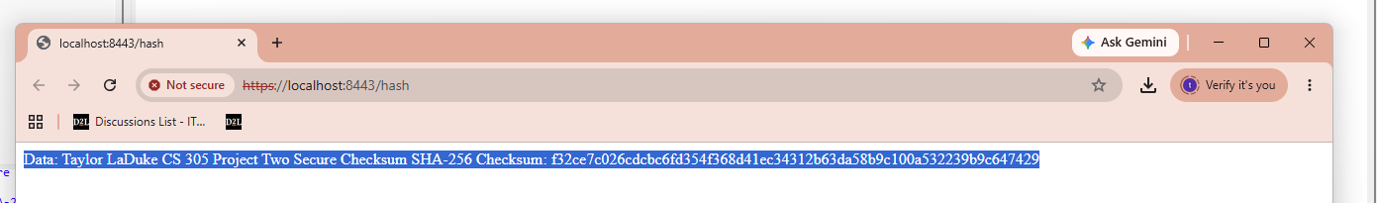

Secure Communications
Insert a screenshot below of the web browser that shows a secure webpage.

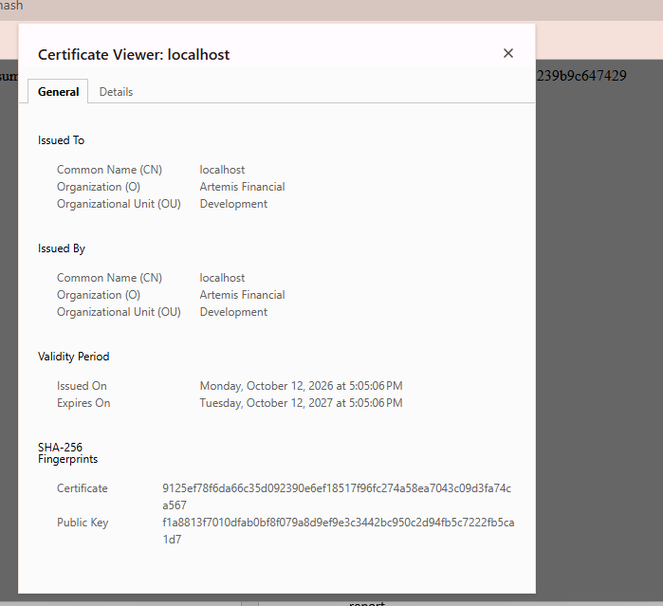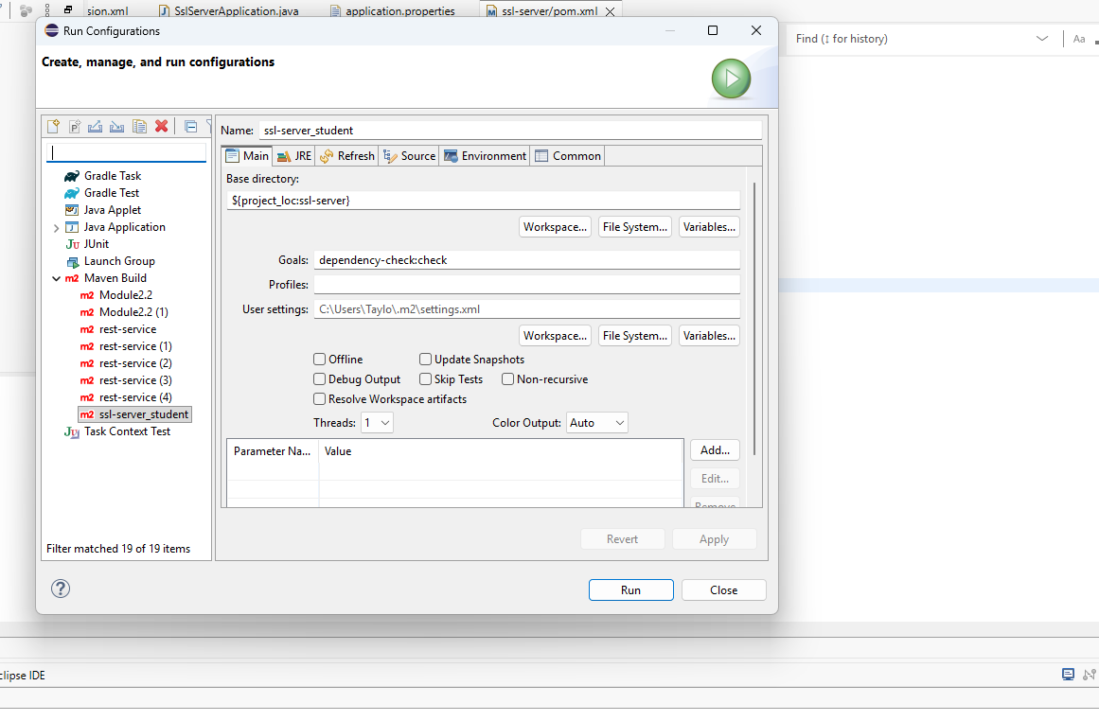

Secondary Testing
Insert screenshots below of the refactored code executed without errors and the dependency-check report.

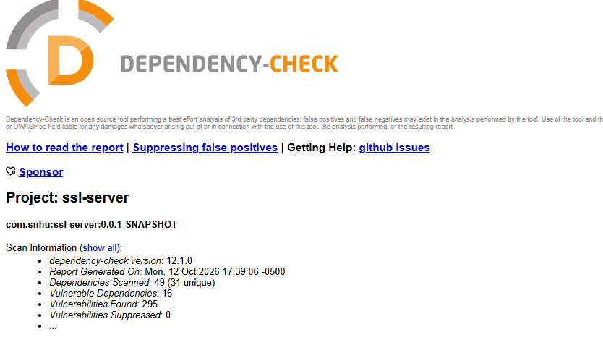

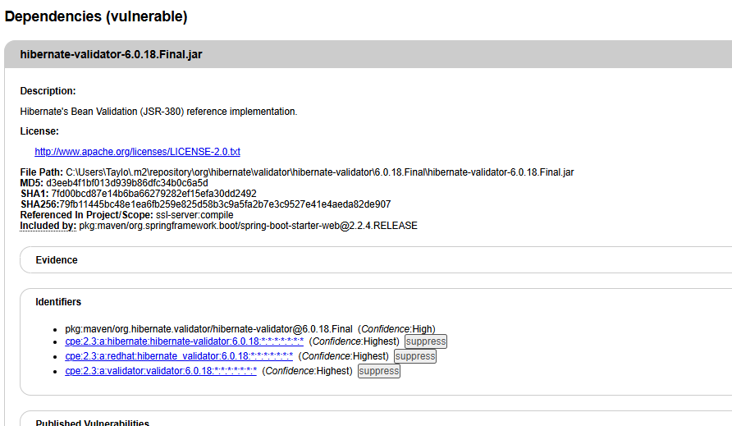

Functional Testing
Insert a screenshot below of the refactored code executed without errors.

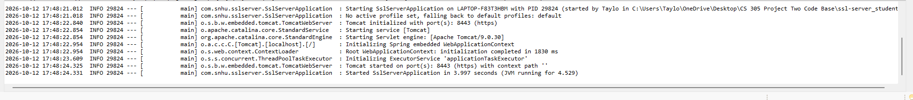

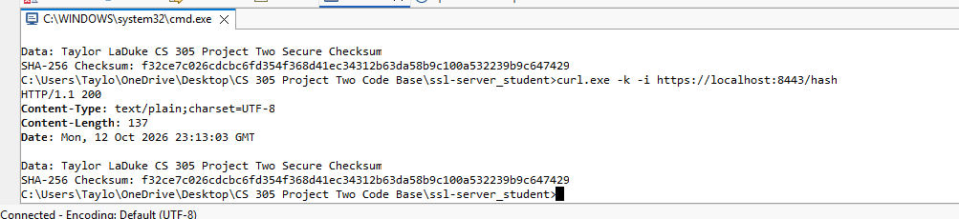

Summary

The Artemis Financial application was refactored to improve security through stronger encryption practices, secure communication, and vulnerability testing. SHA-256 hashing was implemented to generate a checksum that verifies data integrity. A self-signed SSL certificate was created using Java Keytool, and HTTPS was configured on port 8443 to protect data transmitted between the application and clients.
Security testing was conducted using OWASP Dependency-Check version 12.1.0. The scan identified 16 vulnerable dependencies and 295 reported vulnerabilities, demonstrating the need to review and update outdated third-party libraries. The scan also encountered an authentication error with the Sonatype OSS Index service, which limited the completeness of the analysis.
Functional testing confirmed that the application started successfully and that the /hash endpoint returned an HTTP 200 response with the expected SHA-256 checksum. These results demonstrate that the implemented hashing and HTTPS functionality operated as intended. However, additional dependency remediation and security testing are recommended before deploying the application in a production environment.

Industry Standard Best Practices

Secure software development requires implementing security throughout the development process rather than waiting until an application is completed. During the Artemis Financial project, I applied several secure coding practices, including SHA-256 hashing, HTTPS configuration, digital certificate generation, and dependency vulnerability scanning.
One important best practice is using established cryptographic algorithms instead of developing custom encryption methods. Java's MessageDigest class was used to implement SHA-256, which provides a reliable method for generating checksums and verifying data integrity. HTTPS was also configured using a PKCS12 keystore and SSL certificate to help protect information during transmission.
Another essential practice is regularly reviewing third-party dependencies for known vulnerabilities. OWASP Dependency-Check identified several outdated libraries requiring further evaluation. Developers should prioritize confirmed vulnerabilities, update dependencies to supported versions, and repeat security testing after changes are made.
Additional recommendations include protecting keystore passwords through environment variables or secure secret management, using certificates issued by trusted certificate authorities in production, maintaining automated security tests, and following established secure coding guidelines. These practices can help Artemis Financial reduce security risks and maintain a more secure application over time.

